Miss Sweet & Sassy Pageant
Benefiting the Greg Surles Memorial Scholarship Fund

Saturday, June 21st at
St. Clair County High School
16700 US Highway 411• Odenville, Al 35120
Pageant begins at 12:00.
Pageant fee is $50.00 which includes all categories except for
Most Photogenic and the Little Miss Sweatheart Awards!

Categories as follows:
Ages 0-18 months
Ages 19-35 months
Ages 3 & 4 years
Ages 5 & 6 years
Ages 7-9 years
Ages 10-12 years
Ages 13-15
Ages 16-18

*Participants age on the day of the pageant will determine which category they will be in.

Information & Rules:
1. Each age division will have a queen, first alternate, second alternate, and third alternate.
2. Each division will also have side events which are included in the entry fee. The side events are: Best Dress, Prettiest Hair, Prettiest Eyes, and Prettiest Smile.
3. Most photogenic will also be judged in each age group. There is a $10.00 fee to participate in the photogenic contest. All photos MUST be 5x7 with participants name written on back and turned in or received in the mail no later than June 14th. Photos will be returned after judging.
4. There will be a Little Miss Sweetheart Award given in age groups 0-35 months, 3-6 years, 7-12 years and 13-18 years. You may purchase tickets for your favorite contestant in these categories for $1.00 each. The participant with the most money raised will be awarded the Little Miss Beach Babe! You may get donations from friends and family who may not be able to attend the pageant! Just collect their money and turn it in at the Little Miss Sweetheart table!
5. There are no residency restrictions. The pageant is open to anyone!
6. Sunday dress/Pageant dress will be accepted through age 4. Pageant dresses are recommended for ages 5 and up.
7. This is a NOT a Glitz pageant! Absolutely no flippers, hair pieces, or false eyelashes are allowed. Age appropriate make-up is allowed for the stage. No “Toddlers in Tiaras” performances allowed. Your child should walk on the stage, complete their turns, smile at the judges and exit the stage! Points will be deducted for any of these types of performances!
8. Only 1 female will be allowed in the dressing room with each contestant. No food or drinks allowed in dressing rooms.
9. All entries are due by Saturday, June 14th. We will have registration on this day from 12-2 at St. Clair County High School or you may mail your entries to the address below.
10. It is possible that here will be a photographer available to photograph your child before or after the pageant. All questions/concerns should be asked on the photographer, not the host of the pageant. We are not 100% sure at this time if a photographer will be available.
11. Pageant begins promptly at 12:00. The contestants for the 0-35 months must be ready to go on stage by 11:45! If you are late, you will forfeit all monies paid. We will not stop the pageant to wait on anyone who is late. You will not be able to participate once your age group has competed.
12. No score sheets will be given out!
13. Please respect the other contestant’s family. Stay seated until each category is finished before you leave. Everyone wants to be able to see their babies on stage and take pictures! Please also remain as quiet as possible while the MC is introducing each contestant.
14. If you are interested in a vendor space, please contact Tammi Campbell at 205/629-6284. We will be able to arrange this for a small fee $20.00 per booth.
15. We will have an agenda available for times that each category will begin, closer to June 21st. Remember, 0-35 months must be lined up and ready to go on stage at 11:45!
16. Contestant plus 1 female, adult entered free. All others $5.00 at door, 5 and under free!

Wishing each contestant the best of luck and a special “thank-you” for supporting our Scholarship Program!
For more information please contact:
Tammi Campbell
(205)629-6284
(205)238-4985
tcampbell4173@windstream.net

All proceeds from the pageant will go to the Officer Greg Surles Memorial Scholarship Fund, which provides scholarships to graduating seniors throughout the county.

You may mail entries to: Tammi Campbell
P.O. Box 355
Odenville, AL 35120

All entries must be received by Saturday, June 14, 2014!!! No late entries will be accepted! You WILL NOT be able to enter the pageant on the day of the pageant. NO EXCEPTIONS!

***Please make checks payable to: Greg Surles Memorial Scholarship Fund

Miss Sweet & Sassy Pageant
Print neatly! The emcee will be reading from THIS form!

Name:______________________________ Age:___________
Address:___________________________________________________
Phone #: ________________ Alternate Phone #:_______________

School currently attending:_______________________Grade:__________
Parents:____________________Siblings:__________________________
Eye Color:_______________ ___ Hair Color:________________________

Favorites:

Color________________________ TV Show________________________
Music Performer(s):____________________________________________
Song:_______________________________________________________

Hobbies & Interests:
___________________________________________________________
___________________________________________________________
___________________________________________________________
___________________________________________________________

School Subjects & Honors:_______________________________________
___________________________________________________________
___________________________________________________________

Person Most Admired & Why?_____________________________________
___________________________________________________________
___________________________________________________________

How did you hear about our pageant?_____________________________
__________________________________________________________
Email address so we can contact you with a schedule: ________________
______________________________________________________________

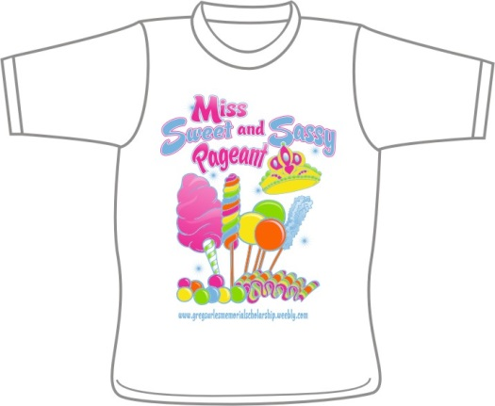
We will have pageant t-shirts available again this year for $10.00! These shirts will be great to wear when the pageant is over! Youth and adult sizes are available.

Contestant Name:_______________________________________
Age Division:___________________________________________

PLEASE CIRCLE SIZES BEING ORDERED

YS YM YL YXL AS AM AL AXL
Total # of shirts ordered:_________________
X $10.00 each :__________________
Total amount due: _______________

***YOU MAY INCLUDE THIS ABOUT WITH THE REGISTRATION FEE SO THAT YOU ONLY HAVE TO WRITE ONE CHECK!

